IDENTIFY NEW BIKES PROJECT

Software Requirements Specification

|  |  |  |  |
| --- | --- | --- | --- |
|  | Prepared By | Reviewed By | Approved By |
| Name | Spin Syndicate | Devathilagai |  |
| Role | Interns | Batch Trainer |  |

**Table of Contents**

Table of Contents…………………………………………………………..….......II

1. Introduction…………………………………………………………………..…1

1.1 Intended Audience……………………………………………….......1

1.2 Project Scope…………………………...……………………………1

2. Overall Description…………………………………………….……………….1

2.1 Operating Environment……………………...……………………....1

3. Requirements……………………………………………………………...…….1

3.1 Login………………………………………………………………….2

3.1.1Description………………………………………………....2

3.1.2 Functional Requirements……..…………………………...2

**1. Introduction**

**ZigWheels** is a vehicle discovery platform that helps users find details about cars and bikes available across India. This project aims to automate the extraction of specific vehicle data and simulate login flows using the ZigWheels website.

**1.1 Intended Audience**

Business Unit (BU) SME

Academy coach

Technical Trainer

**1.2 Project Scope**

This document outlines, at a functional level, the vehicle-related business operations supported by the ZigWheels platform and the key rules governing them. It also incorporates both high-level and detailed technical requirements relevant to the automation process.

The scope leverages insights from proposed test frameworks, platform navigation flows, and architectural components of the ZigWheels site. As part of the detailed analysis phase, this document will include:

* Classification of automation requirements grouped by feature and page context
* A breakdown of each automated process, specifying inputs (filters, search terms), expected outputs (vehicle listings, messages), and the steps involved in data handling and navigation
* Validation guidelines for extracted information, form interactions, and error capture logic across different sections of the website.

**2. Overall Description**

**2.1 Operating Environment**

**OS:** Windows

**Type:** Web Application (ZigWheels)

**Browser Support:** Chrome, Edge

**Project Management Tool:** Jira

**Testing Tools:** Selenium, TestNG, Apache POI, Junit, BDD Cucumber, Allure, Log4j

**3. Requirements**

This part of the requirements document serves to present the "ZigWheels for identifying new bikes" of the application, we need to extract details like bike name, price, and launch date—filtered by Honda models priced under ₹4 lakhs and to automate the process and organize results for easy access and validation.

**3.1.1 Functional Requirements**

**3.1.1.1 Req0001**

**Req0001a-**The user enters random text into the ZigWheels search box and initiates the search by pressing Enter or clicking the Search icon.

**Req0001b**-To verify that the page either remains on the Homepage or displays a search results page indicating no matching vehicles found.

**Req0001c-**The user navigates to the ZigWheels homepage, hovers over the “More” menu in the header section.

**Req0001d-** The user The user selects the “Used Cars” option from the dropdown list under “More”.

**Req0001e** – Verify that the browser navigates to the Used Cars page by checking the URL.

**Req0001f** – Verify the page title corresponds correctly to the Used Cars section.

**3.1.1.2 Req0002**

**Req0002a**- The user opens the ZigWheels homepage and clicks on the “Login/Signup” button in the top navigation.

**Req0002b-** The user selects the “Login with Google” option to initiate authentication.

**Req0002c-** The user enters invalid credentials (e.g., wrong email or password) in the Google login window.

**Req0002d-** The system displays an error message indicating login failure; capture and verify the displayed message.

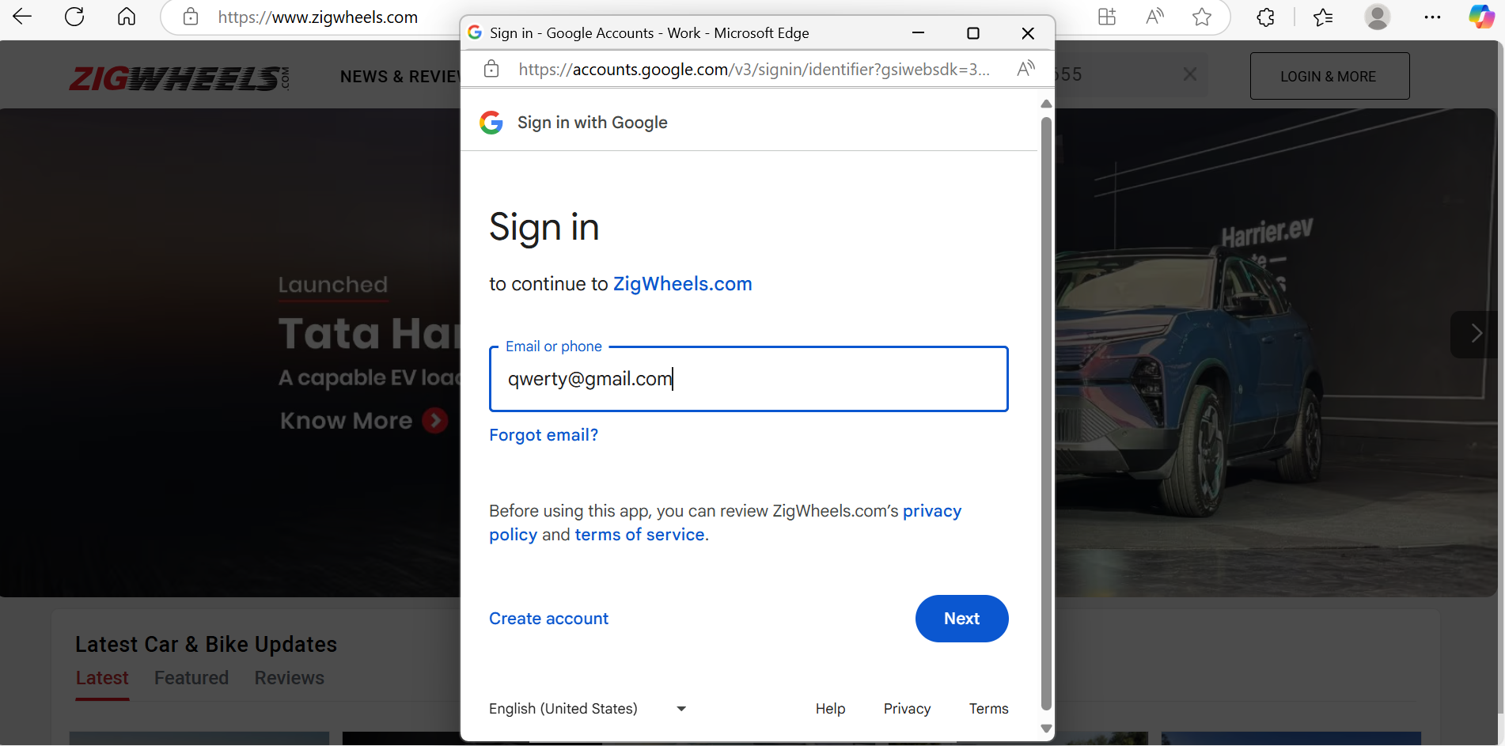

**3.1.2.3 Req0003**

**Req0003a**-The user navigates to the ZigWheels homepage and clicks the “Login/Signup” button located in the top-right corner.

**Req0003b-** The user selects the “Login with Apple” option from the available login methods.

**Req0003c-**The user enters invalid login credentials into the Apple sign-in window.

**Req0003d-**Leave The system displays an error message indicating login failure; capture and validate the displayed message.

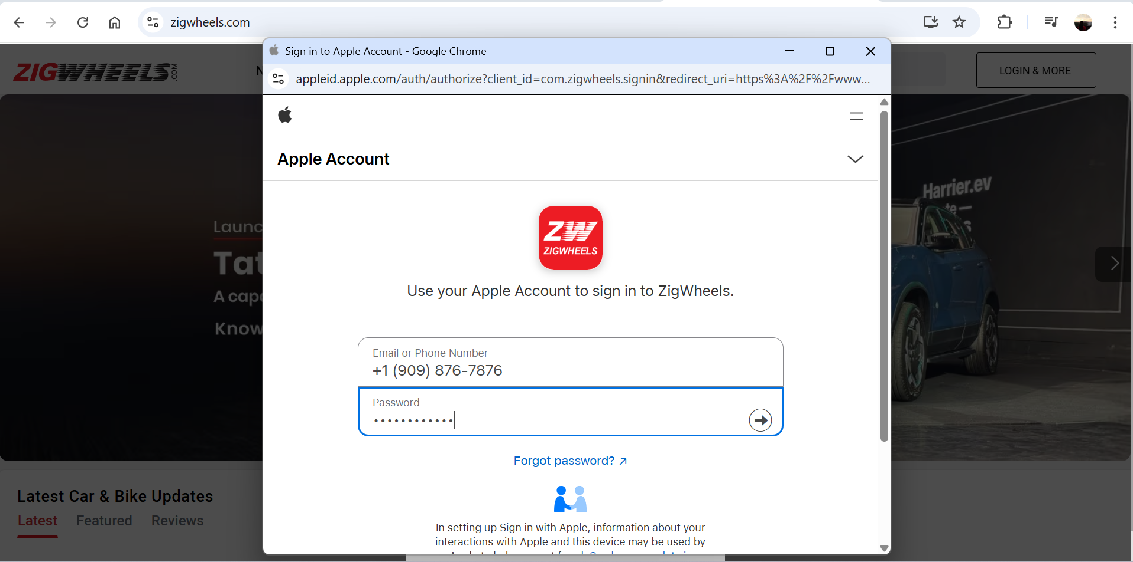

**3.1.2.4 Req0004**

**Req0004a**-The user navigates to the ZigWheels homepage and hovers over the “More” option in the top menu.

**Req0004b-** The user clicks on the “Used Cars” link from the dropdown menu under “More”, On the Used Cars page, locate the “Select Location” dropdown and choose “Chennai” as the city.

**Req0004c-**Locate the “Popular Models” filter section and apply the available filters.

**Req0004d-**Confirm that a list of popular used car models is displayed on the page, relevant to the selected location.

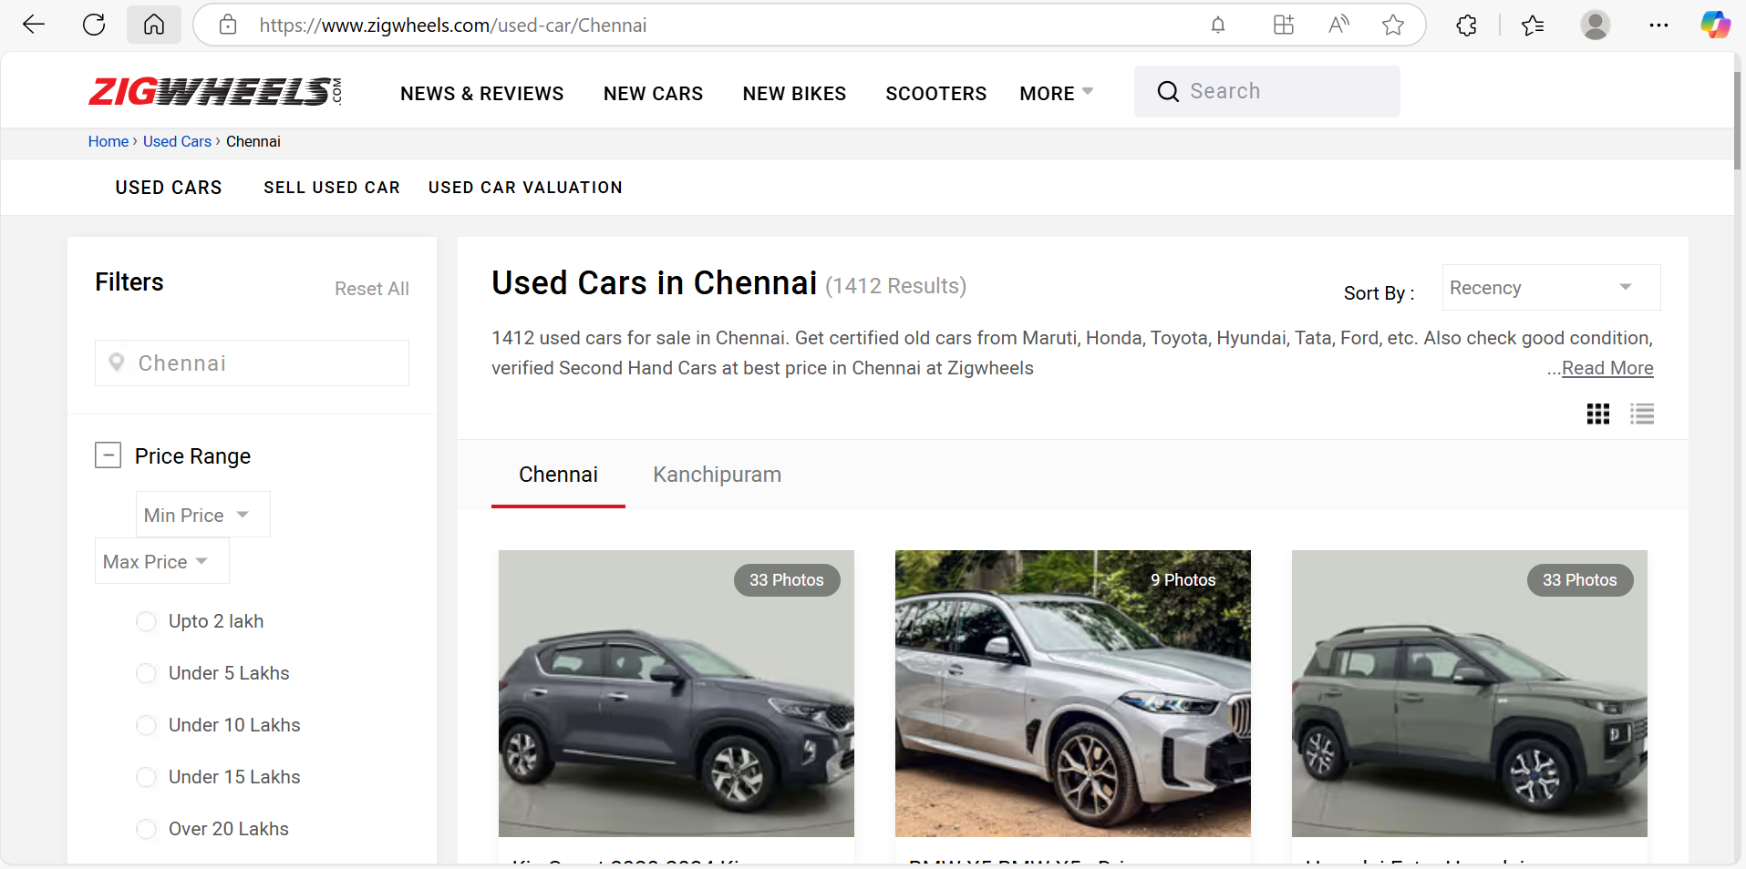

**3.1.2.5 Req0005**

**Req0005a**-The user enters invalid search data on ZigWheels homepage and triggers search.

**Req0005b-** Verify “search term not found” message is shown.

**Req0005c-** Click “New Bikes” → enter “Honda” → click Search. Click “Read More” and apply “Upcoming Bikes” and “Under 4 Lakhs” filters.

**Req0005d-**Scroll to FAQs; verify they relate to Honda models and matching bikes are listed

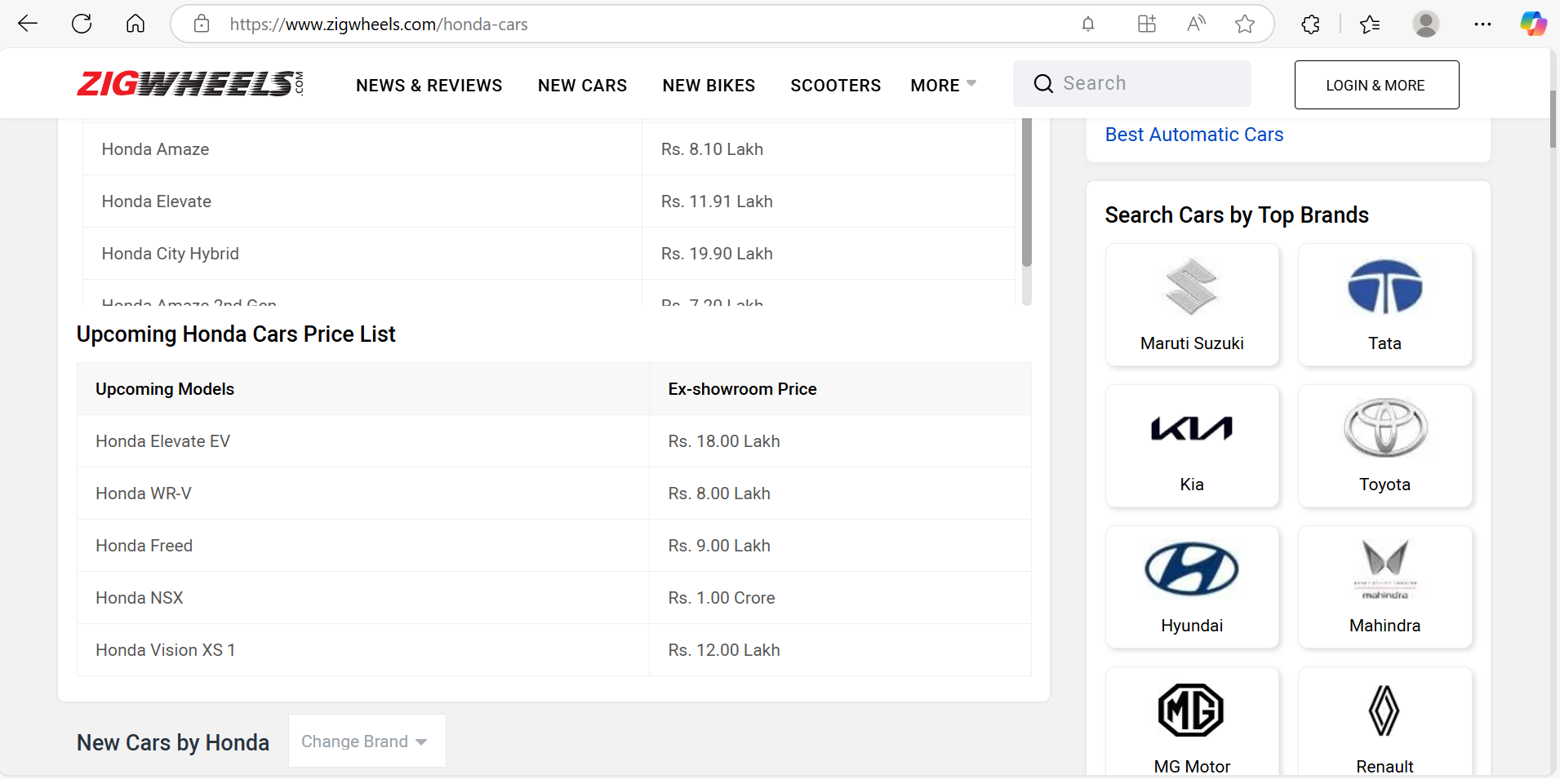

**3.1.2.5** **Req0006**

**Req0006a**-The user enters invalid search data on ZigWheels homepage and triggers search.

**Req0006b-** Verify “search term not found” message is shown.

**Req0006c-** Click “New Bikes” → enter “Honda” → click Search. Click “Read More” and apply “Upcoming Bikes” and “Under 4 Lakhs” filters.

**Req0006d-**Scroll to FAQs; verify they relate to Honda models and matching bikes are listed

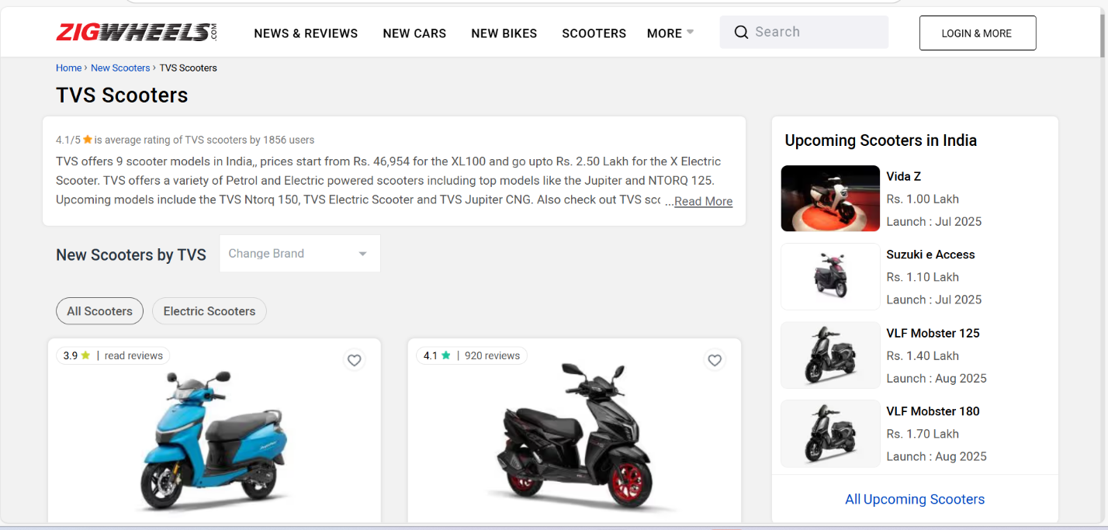

**3.1.2.6 Req0007**

**Req0007a** – The user navigates to the ZigWheels Homepage.

**Req0007b** – The user hovers over the "More" element in the website header.

**Req0007c** – The user clicks on "Used Cars" from the "More" dropdown.

**Req0007d** – The user selects "Chennai" as the location for used cars.

**Req0007e** – The user clicks on the "More Filters" or "All Filters" button/link.

**Req0007f** – Verify the presence and visibility of key filter categories.

**3.1.2.7 Req0008**

**Req0008a** – The User opens ZigWheels homepage and navigates to “Forum” via the “More” dropdown.

**Req0008b** – The User filters by Vehicle Type: “Car”, Make: “Toyota”, Model: “Fortuner”.

**Req0008c** – The User clicks “Search” and joins the Fortuner community.

**Req0008d** – The User selects “Login with Facebook” and enters invalid credentials.

**Req0008e** – The System displays login error message on the Facebook page.

**3.1.2.8 Req0009**

**Req0009a** – The User opens ZigWheels homepage and selects “New Cars” from the navigation menu.

**Req0009b** – The In the “Quick Research” section, user clicks on “Service Centers”.

**Req0009c** – The User enters a city name and selects a car brand from the filters.

**Req0009d** – The User clicks “Directions” or “Get Location” and captures the map page URL.

**3.1.2.9 Req0010**

**Req0010a** – The User visits ZigWheels homepage and clicks on “New Cars”.

**Req0010b** – The User accesses “EMI Calculator” from the Quick Search section.

**Req0010c** – The User selects car Make, Model, and Variant, then clicks “Check EMI”.

**Req0010d** – In the EMI Calculator, user adjusts Down Payment and Interest Rate sliders, selects Tenure.

**Req0010e** – The System displays calculated EMI amount under “Your Monthly EMI”.

**3.1.2.10 Req0011**

**Req0011a** – The user navigates to the ZigWheels Homepage.

**Req0011b** – The user scrolls into the Top Bike Brand section.

**Req0011c** – The system retrieves the list of all displayed Top Bike Brands.

**3.1.2.10 Req0012**

**Req0012a** – The user navigates to the ZigWheels Homepage.  
**Req0012b** – The user clicks on **"News & Reviews"** and waits until the page loads.  
**Req0012c** – The user clicks on **"New Cars"** and waits until the page loads.  
**Req0012d** – The user clicks on **"New Bikes"** and waits until the page loads.  
**Req0012e** – The user clicks on **"Scooters"** and waits until the page loads.  
**Req0012f** – The system checks if the **ZigWheels logo** is present.  
**Req0012g** – After clicking the logo, the system verifies that the user is redirected to the Homepage.

